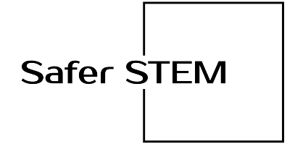
CTE (Career & Technical Education)
STUDENT SAFETY ACKNOWLEDGEMENT FORM

Student |  | Student #
Teacher |  | Date
Subject |  | Room #

PURPOSE:
This CTE program is designed to be practical by providing hands-on skills involving the use of tools, machinery, apparatus and other items typically found in the workplace. The CTE teacher will introduce students to various activities involving these products that may present potential hazards or risks, therefore, ALL students must conduct themselves in a safe and responsible manner at all times. Students are expected to follow safety procedures at all times, ask for clarification if they are not 100% certain on the safer operation of a tool, and to notify the teacher if they discover a damaged or broken tool or piece of machinery. Students making poor choices and exhibiting unwanted or dangerous behaviors will be subject to consequences including removal from the room.
GENERAL SAFETY PROCEDURES:
- Students are expected to behave respectfully at all times; understand that fooling around or horseplay causes injuries.
- Do not enter lab / shop / room unless a teacher is present.
- Students must always wear personal protective equipment (PPE) including safety goggles, safety glasses with side lenses, protective gloves, ear protection and other items as directed by the instructor. Failure to wear PPE properly will result in the student being removed from the room.
- Students must follow safety precautions specific to each tool, machine, apparatus or equipment being used. If unsure about the safer operation of the equipment, the student must speak to the teacher and gain a thorough understanding before operating any tool or machinery.
- Students who have long hair (past shoulder) must keep it held back with a hairband, hairnet, or worn in a ponytail as this is a health hazard when working in a CTE laboratory or shop classroom due to the proximity of moving and rotating parts of the machinery used.
- Students are only allowed to wear close- toe shoes; no sandals or flip flops are permitted in the CTE laboratory.
- Students are advised to avoid or tie back loose clothing that might get caught in tools or machines in the CTE laboratory. Wear appropriate clothing.
- Students must remove all jewelry before operating machinery including watches, rings, necklaces, earrings and other decorative items as this is a health hazard.
- Students are to stay behind the safety lines near the equipment unless you are instructed to operate machinery by your teacher and have a comprehensive understanding of the safer operating procedures including safety procedures.
- Students are to concentrate on the daily or weekly project or task and do not distract others in the room
- Students are to immediately notify teacher of damaged or broken tools or equipment as this is a safety risk for themselves and others.
- Students must always use all tools and materials appropriately and only for their intended purpose following safety instruction guidelines and training from the teacher.
- Students are to keep their work areas neat and clean at all times; this includes properly storing tools and materials according to the organizational system in your CTE lab.
- Students are to notify the CTE teacher if you are taking medication that identifies and precautions regarding operating machinery. This is important for your personal safety.
- In the unlikely event of an accident, immediately report any injuries to the teacher.
- Students are to strictly follow additional machine specific safety and operating procedures to ensure that they and their classmates are safer in the CTE lab.
- Students must score 100% on all safety tests before operating any tool, equipment or machines. This is to demonstrate competency and to have a solid baseline understanding of the safer operating procedures for the various machinery, tools, and equipment in the CTE laboratory or shop classroom.
I have read and understand the general safety guidelines above. My teacher has explained all of them to me and provided a demonstration. I fully understand and agree to follow these CTE safety rules and practices at all times. If at any time, I do not understand the safe way to use any tool, machinery, or hazardous materials, I will ask my teacher before I proceed.

Student’s Signature |  | Date
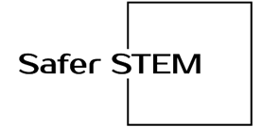

CTE STUDENT SAFETY ACKNOWLEDGEMENT FORM

I, (student’s name) have read and agree to follow each of the safety procedures set forth in this safety acknowledgment form. I realize that following these safety rules will help ensure my own safety along with the safety of my classmates and instructors. I will cooperate with my instructors and classmates to maintain a safe learning environment. I will follow written and verbal instructions provided by the instructor and on the various tools, equipment and machines and will only use appropriately. I will accept responsibility for my actions and understand that I will be subject to disciplinary action if I violate safety rules or procedures.

(Student’s Signature) (Date)

Dear Parent/Guardian:
The school and the district are excited that your child is participating in a career & technical program that will provide them real world experience to prepare them for college and careers. Students will not be allowed to work in the CTE lab or with tools, machinery, or hazardous materials until they return this signed contract with student and parent signature acknowledging understanding of safety rules and procedures and have scored 100% on all safety tests. Students will be using the following tools and machinery throughout the year.
All Students | 9th Graders | 10th Graders | 11th Graders | 12th Graders

I have reviewed the CTE Lab rules and procedures with my child and agree to hold my student to these standards. My child has my express permission to use these tools and machinery under adult supervision after they have been properly trained. I understand the risks involved in using these tools and machinery.

(Parent’s Signature) (Date)

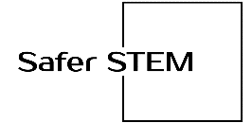
(Parent Printed Name) (Phone Number)

